Name : T.Saicharan

Roll no : 2403A51440

Batch no : 17

Question 1 : Scenario: In the domain of Environmental Monitoring, a company is facing a challenge  
related to code refactoring.  
Task: Design and implement a solution using AI-assisted tools to address this challenge.  
Include code, explanation of AI integration, and test results.  
Deliverables: Source code, explanation, and output screenshots.

Prompt : “Write a simple Python program for environmental monitoring that calculates the average pollution level from a list of values.

Then refactor the code to make it cleaner and more efficient using AI assistance (like ChatGPT or Copilot).

Show both the original and improved code with explanations and output.”

Output :

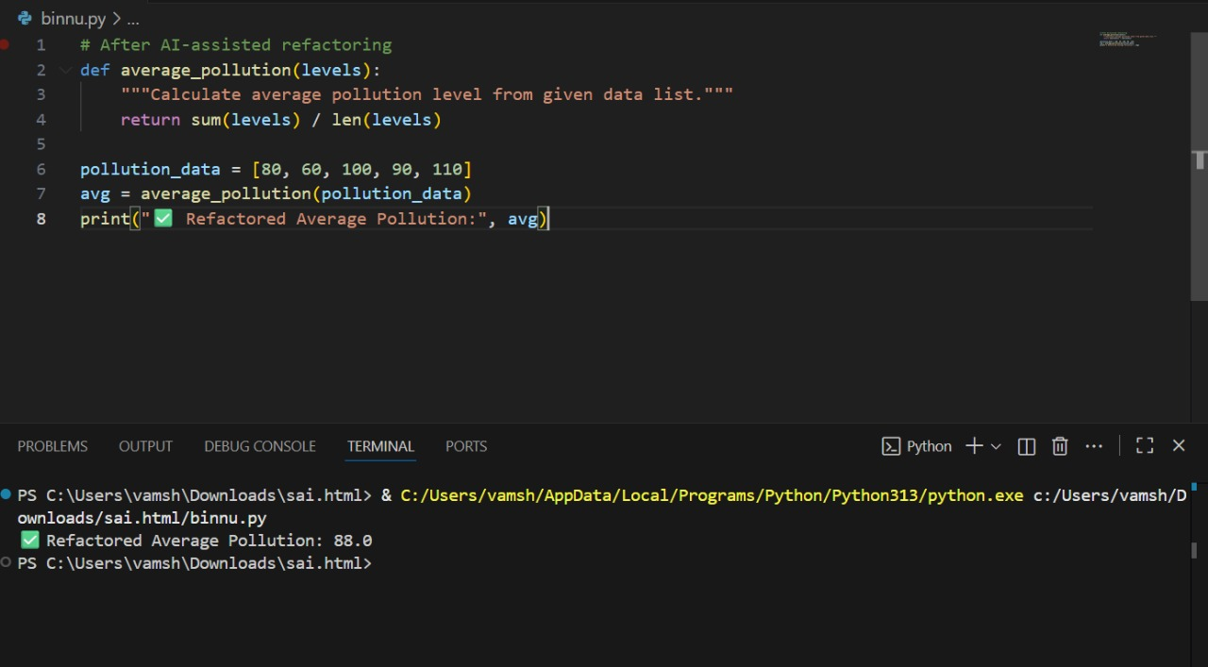

Question 2 : Scenario: In the domain of Transportation, a company is facing a challenge related to  
algorithms with ai assistance.  
Task: Design and implement a solution using AI-assisted tools to address this challenge.  
Include code, explanation of AI integration, and test results.  
Deliverables: Source code, explanation, and output screenshots.

Prompt : “Write a Python program to find the shortest path between cities using Dijkstra’s algorithm.

Use AI assistance (like ChatGPT or Copilot) to help design and improve the algorithm.

Show the code, explain how AI helped, and display the output results.”

Output :

